RINGS-A000-EUR-Italy-Rome- Legio XXX Ulpia Victrix

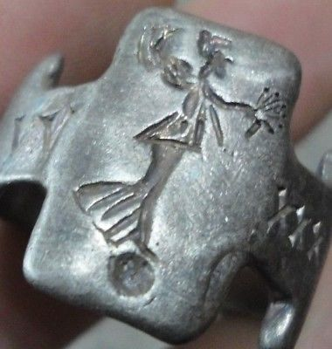

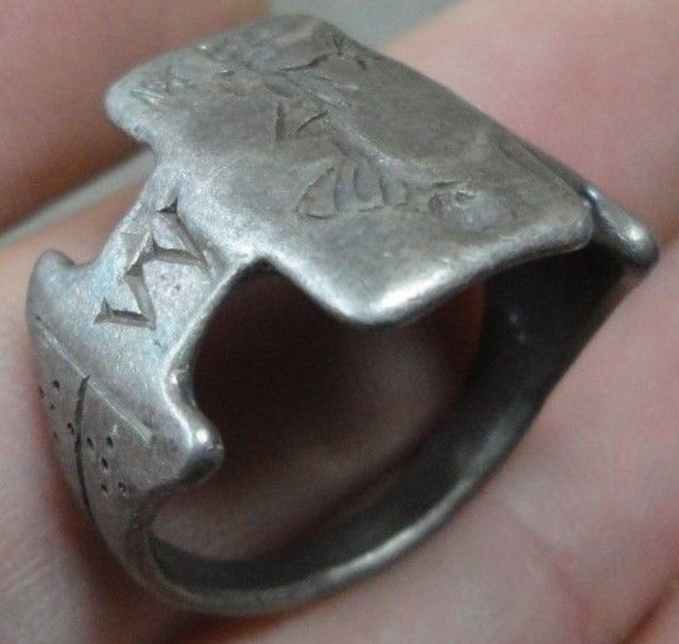 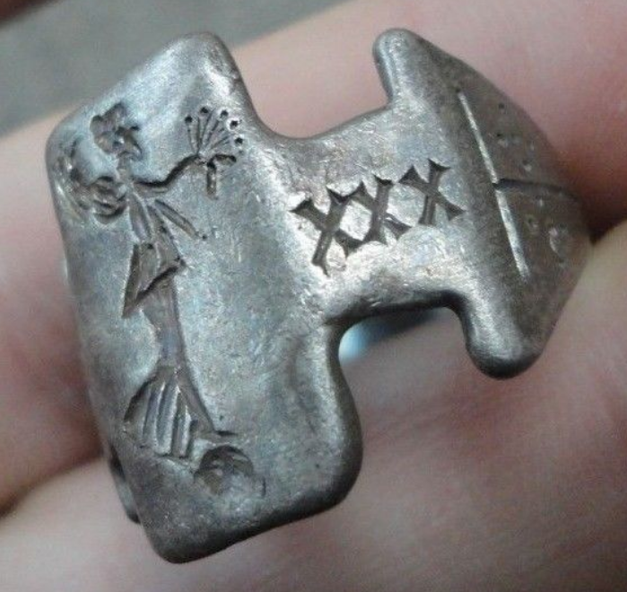

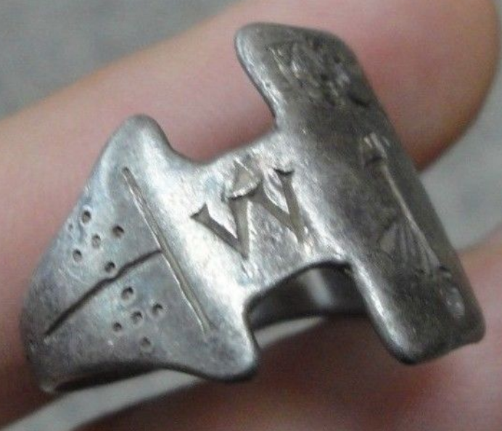

Legio XXX Ulpia Victrix

Legio XXX Ulpia Victrix. Legio trigesima Ulpia victrix ("Trajan's Victorious Thirtieth Legion") was a legion of the Imperial Roman army. It was founded in AD 100 by the emperor Trajan (r. 98-117) for service in the Dacian Wars. The legion was active until disbandment of the Rhine frontier in the beginning of the 5th century. Ulpia is Trajan's own gens (Ulpia), while the cognomen "Victrix" means "victorious", and was awarded after the valliant behaviour in the Dacian wars.

INSCRIBED - GODDESS VICTORIA - Roman legionary combat symbol/emblem on the Legion " V V - XXX "

EXTREMELY RARE **Roman SENATORIAL LEGIONARY SILVER ring.**

SOLID SILVER - Wearable <> 9.85 grams <>

**<> 21.30mm. = 0.85" Inner diameter <>**